MINI PROJECT ON

**COLLEGE TRANSPORT MANAGEMENT SYSTEM**

Submitted in partial fulfillment of 2ndSemester

MASTER OF COMPUTER APPLICATIONS

Of

Visvesvaraya Technological University

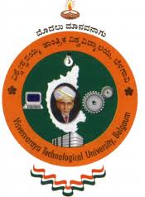

**MD MIRAJ ANSARI**

**1AY18MCA14**

Under the Guidance of

**Dr. Ramesh Hegde**

**Prof. Susmita J A Nair**



# Acharya Institute of Technology

Acharya Dr.SarvepalliRadhakrishna Road,

Soldevanahalli, Bangalore – 560107

[www.acharya.ac.in](http://www.acharya.ac.in)

2018-19

ACHARYA INSTITUTE OF TECHNOLOGY

PG Department of Computer Applications

Soladevanahalli, Hesaraghatta Main Road,

Bengaluru 560107.



**C E R T I F I C A T E**

This is to certify that the project entitled

**COLLEGE TRANSPORT MANAGEMENT SYSTEM**

is a bonafide work carried out by

**MD MIRAJ ANSARI**

**1AY18MCA14**

in partial fulfillment of 2nd semester Master of Computer Applications

during the academic year 2018-19.

**PROJECT GUIDE Head of the Department**

Examiner **………………………..**